HIGHLIGHTS FROM PROVINCIAL BUDGET 2014-15
AND IMPLICATIONS FOR THE DISTRICT
March 6, 2014

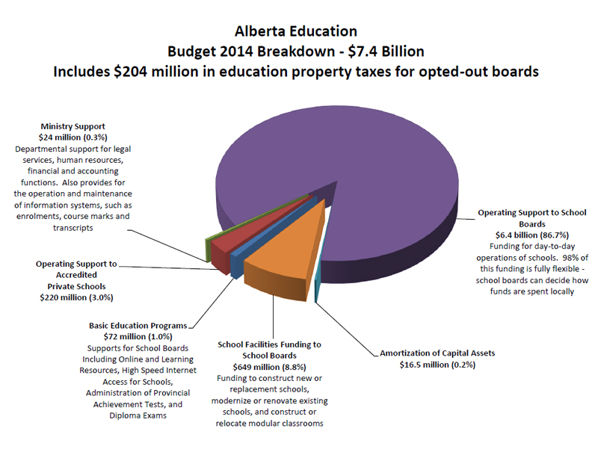
Key Highlights – Provincial Budget 2014-15:
- Budget 2014-15 - $7.4 billion for Education, an increase of $186 million
- Ministry’s operating budget (excluding capital spending) increase by $201 million, or 3.2 per cent.
- Provincial student enrolment is projected to grow by 3% or 18 000 new students.
- Both inclusive education and small class size initiative will receive a two per cent grant rate increase for the 2014/2015 school year.
- $476 million for the continued operations and maintenance of school buildings through the plant operations and maintenance grant.
- $402 million for inclusive education funding to ensure school jurisdictions have the flexibility to meet the unique needs of all students in an inclusive setting.
- $377 million is spent to support the government portion of the current services contributions to the Alberta Teachers’ Retirement Fund to account for the growth of the teacher work force. With the additional $455 million paid by Treasury Board and Finance for the unfunded liabilities for the pre-1992 services, total government contributions will be $832 million for 2014/2015.
- $282 million for student transportation to support a safe transportation system for nearly 300,000 K-12 students across Alberta.
- $265 million for the class size funding to reflect the two per cent grant rate increase and significant enrolment growth in Early Childhood Services (ECS) to Grade 3.
- $113 million for Equity of Opportunity to ensure equitable access to education programs for all Alberta students, especially those attending rural schools.
- $61 million for Regional Collaborative Service Delivery (include formerly Student Health Initiative, Children and Youth with Complex Needs, and Regional Educational Consulting Services) to support schools and community partners to meet the needs of children and youth (ECS to Grade 12), as well as families who have children and youth with complex needs (birth to 20).
- $5.2 million for eligible school boards to bring their average teachers’ salary (with four years of education and 10 years of education, or C4MAX) to the Adjusted Provincial Average as outlined in Part B of the Framework Agreement between the Government of Alberta, the Alberta Teachers’ Association and the Alberta School Boards Association.
- Total school facility funding reaches $649 million to fund the construction of new schools, modernization of existing schools, modular classrooms and Infrastructure Maintenance and Renewal (IMR) funding.
- Infrastructure Renewal and Maintenance Funding: $100 million for IMR, an increase of $23 million compared to the previous year.

Implications for Our District
- Alberta Education based on their enrolment projections is predicting a funding increase of 3.7%. This represents a funding increase from $341,640,000 for 2013-14 to $354,270,000 for 2014-15.
  - Using our District enrolment projections which are higher than Alberta Education enrolment projections our overall funding from Alberta Education increases from estimated funding of $341,640,000 for 2013-14 to estimated funding of $355,882,000 for 2014-15 which is an increase of $14,242,000 or 4.1%.
- District projected enrolment will be 38 456 which is 2.75% higher over last year’s 37 427. This is an increase of 1029 students.
- There were no budget reductions in any funding categories.
- We have been funded for projected enrolment increases for the next school year.
- The funding model continues to be on a per student rate for most categories.
- There was no increase to the basic rate that primarily funds our district.
- Class size funding increased by 2% for 2014-15, grades ECS to 3.
- Increase in funding is 4.1% overall that is essentially for our projected enrolment increases.
- Funding for inclusive education is increased to $23,430,000, ECSD grant increase of 2%.
  - School boards will continue to have flexibility to apply the funding in a way that best meets their local needs.
- Reduction in School Boards Administration and Spending continues to be reduced by 10% from a minimum of 3.5%. For Metro boards the 10% reduction was based on 3.5% of district expenses, ECSD funding reduction is estimated at $1,586,000. The district’s administration and spending is at 3.04%, 0.46% below the 3.5% minimum.
- The Equity of Opportunity grant was increased from $3,497,000 to $3,603,000 this is an increase of 3.04%. This increase is based on projected increase in enrolment. This grant in 2012-2013 was $5,152,000, ECSD reduction of $1,549,000.
- The “Small School by Necessity” grant continues to be eliminated for all metro boards (past allocation in 2012-2013 was $1,040,000).
- Plant Operations & Maintenance grant (PO&M) grant is increased by 3.04% from $26,187,000 to $26,983,000. The funding relating to coded students and Metro school jurisdictions are no longer eligible for the SSBN (Small School By Necessity) component of this funding.
- IMR (Infrastructure Maintenance Renewal) funding was increased by 30%. IMR for 2013-2014 is $4,733,000; the estimated amount for 2014-2015 is $6,153,000.
- Funding for ESL students continues to be funded for a maximum of 5 years. The maximum of 7 years from 2012-2013 was not reinstated.
- Fuel Price Contingency Funding discontinued April 1, 2013 was not reinstated.
- Alberta Distance Learning Center (ADLC) courses funding continues to be reduced to 44% of the respective CEU Tier rate from 2012-2013.
- Tier 4 CEU rate remains the same for Work Experience and Special Projects courses of $112.48. This was a reduction of $75 from the previous rate of $187.48 for these CEU’s, 2012-2013.

